Math 1 Unit 1 Review Sheet Name:_________________________________
Show all work and answer all parts of all questions.

Given information: | Type of sequence? | Common difference or ratio = | Increasing or decreasing? | Recursive equation: | Explicit equation: | The seventh term:
1)

$5, 7, 9, 11, . . .$

2)

$9, 3, 1, \frac{1}{3}, \frac{1}{9}, …$

3)

$$1.50, 2.25, 3, 3.75, . . .$$

4)
$$\frac{2}{5}, 2, 10, 50, . . .$$
5)
0 | 1 | 2 | 3 | 4
16 | 10 | 4 | -2 | -8

6)
1 | 2 | 3 | 4 | 5
80 | 20 | 5 | $$\frac{5}{4}$$ | $$\frac{5}{16}$$

Given information: | Type of equation? | Initial term? | Type of sequence? | Common difference or ratio = | Other type of equation
7) $f\left(n\right)=3+7n$
8) $\begin{matrix}f\left(0\right)=6 \\ f\left(n\right)=2f(n-1)\end{matrix}$
9) $\begin{matrix}f\left(1\right)=20 \\ f\left(n\right)=\frac{2}{5}f(n-1)\end{matrix}$
10) $f\left(n\right)=300{\left(\frac{1}{3}\right)}^{\left(n-1\right)}$
11) $f\left(n\right)=\frac{1}{2}∙3^{n}$
12) $\begin{matrix}f\left(0\right)=15 \\ f\left(n\right)=f\left(n-1\right)-5\end{matrix}$
Math 1 Unit 1 Review Sheet, continued Name:_________________________________
Show all work and answer all parts of all questions.

$$n$$ | 1 | 2 | 3 | 4 | 5 | 6 | 7 | 8 | 9 | 10 | 11
$$f(n)$$ | 27 | 24 | 21 | 18 | 15 | 12 | 9 | 6 | 3 | 0 | -3

Use the table above to answer #13-16
13) If $f(n)=15$, what is the value of $n$? ________ then find $f(n+4)$_______ and $f(n-2)$_______

14) If $f(n)=24$, what is the value of $n$? ________ then find $f(n+6)$_______ and $f(n+8)$_______

15) If $f(n)=3$, what is the value of $n$? ________ then find $f(n-7)$_______ and $f(n+1)$_______

16) If $f(n)=18$, what is the value of $n$? ________ then find $f(n-1)$_______ and $f(n+3)$_______

Find the missing terms of each arithmetic sequence

17) | $$n$$ 1 2 3 4 5 6 7  $$f(n)$$ 4 46 | 18) | $$n$$ 3 4 5 6 7  $$f(n)$$ 50 22
19) | $$n$$ 0 1 2 3 4 5 6 7  $$f(n)$$ 96 75 | 20) | $$n$$ 4 5 6 7 8  $$f(n)$$ 17 77

Find the missing terms of each geometric sequence

17) | $$n$$ 1 2 3 4 5  $$f(n)$$ 2 512 | 18) | $$n$$ 2 3 4 5  $$f(n)$$ 13 351
19) | $$n$$ 0 1 2 3 4 5 6  $$f(n)$$ 384 6 | 20) | $$n$$ 7 8 9 10 11  $$f(n)$$ 5625 9

For each situation, identify the two variables, make a table of values, a (fully labeled) graph, and write both recursive and explicit equations. Show all work on a separate sheet of paper.
21) Jai’Lin is saving money to buy a boat. He has $400 and plans to save $50 more every week until he has enough.

22) Liza is starting a new work out plan. She plans to do 5 sit-ups the first day, then add 2 more sit-ups every day.

23) Maria started a new job. She was promised a salary of $35,000 for the first year and a 5% increase every year.

24) Julian is determined to eat healthier. He realizes that he currently consumes about 50 mg of sugar in a typical day. He plans to reduce that amount by 5 mg every day.

25) Haylie worked all summer and saved $450. She plans to spend $10 per week on after school snacks.

26) Aidan is interested in the stock market. He has been watching one particular company’s value. It was originally valued at $250 per share. It has lost $12% of its value every week.

The first four figures of a picture pattern are shown. On a separate sheet of paper, a. Describe how each pattern is growing visually. b. Identify each sequence as arithmetic, geometric, or neither. c. If the sequence is arithmetic, identify the common difference; if the sequence is geometric, identify the common ratio. d. Write an explicit formula (if possible)
27) 29) 30)
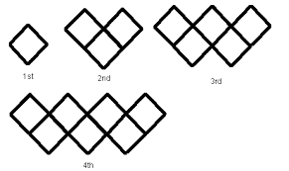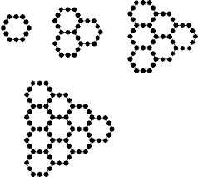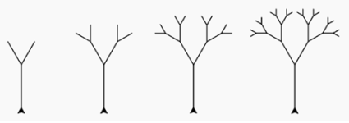

$n=$figure number $n=$figure number $n=$figure number
$f(n)=$number of diamonds $f(n)=$number of hexagons $f(n)=$number of branches

Choose the best answer.
31) A rabbit population starts with 10 rabbits and doubles each year for three years. How many rabbits will there be at the end of the three years?
A. 30 B. 80 C. 150 D. 630
32) A single bacterium lands in your mouth and starts growing by a factor of 4 every hour. After how many hours will the number of bacteria exceed 1,000?
A. One hour B. Three hours C. Five hours D. Twenty hours

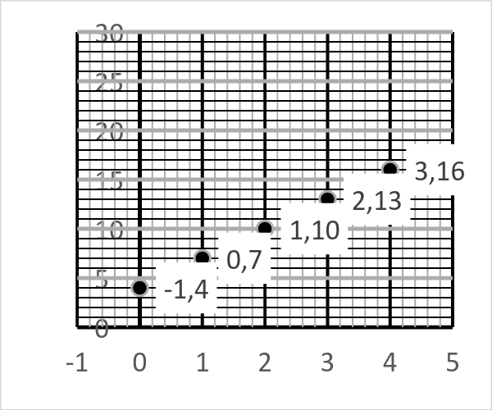
33) What is the recursive function that fits with the sequence shown in the graph below?
  - 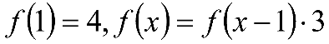
  - 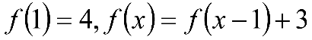
  - 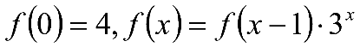
  - 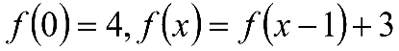

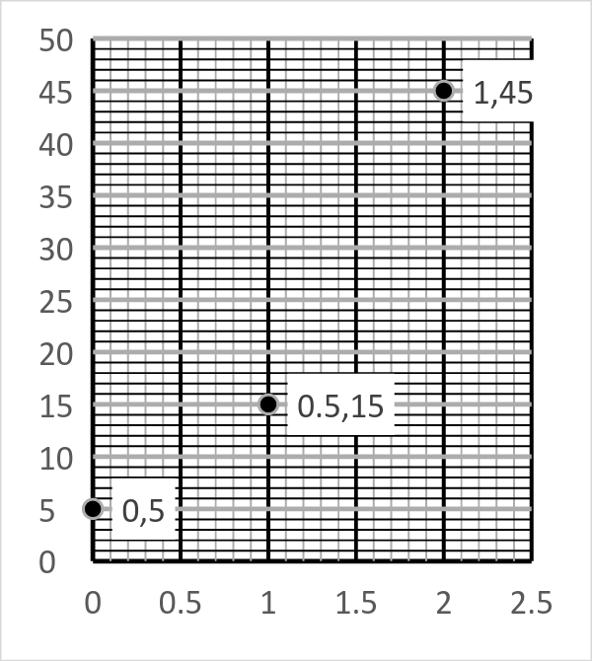
34) What is the explicit function that fits with the sequence shown in the graph below?
  - 
   