Math 1A Unit 2 Review Sheet, Part 3 Name:_________________________________
For #1-4, determine whether the function is: a. linear exponential or neither, b. increasing or decreasing, and c. discrete or continuous.
Number of Years | 0 | 1 | 2 | 3
Value of the boat | 44,000 | 33,000 | 24,750 | 18,562.5
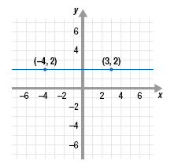
1. 2. $y=\frac{1}{2}x^{2}$
3.

4. Janet wants to know how many seats are
in each row of the theater. Jamal tells her that
each row was 2 seats more than the row in front of it.
The first row has 14 seats.

5. The equation$y=60000{\left(1.04\right)}^{x}$ models the amount of money in a bank account over several years.
a. Is the bank account increasing or decreasing in value?
b. By what percent is the value increasing or decreasing?
c. What is the initial value of the bank account?

6. Leesville Road High is raising money for JDRF. Dr. Muttillo made an initial contribution and the students have agreed fundraise according to the model $y=50{(2)}^{x}$. Sanderson High School is competing with Leesville and their principal also made an initial contribution, but they have agreed to follow the model $y=100x+50$.
a. What does the 50 represent in the Leesville model?
b. What does the 2 represent in the Leesville model?
c. What does the 100 represent in the Sanderson model?
d. Which school will raise more money in the beginning? Which school will raise more money in the long run? Explain your answers.

7. A line has the equation $y=\frac{1}{3}\left(x+3\right)-1$.
a. What is the slope of this line?
b. Name a point that lies on the line.
c. Graph the line on graph paper.

8. An equation goes through the points (8,-9) and (-4,15).
a. Find the slope of the line.
b. Write an equation for this line in point-slope form.
c. Write an equation for this line in slope intercept form.

9. The Chicago Cubs decreased its ticket price by a constant rate each year. A ticket cost $77.55 in 2005, but only $49.50 in 2012. Find the rate of change of the ticket price.

10. What is the equation of the line that passes through the point (5, 19) and has a slope of $m=12$ and is written in slope–intercept form?
11. What is the equation of the line that passes through the point (16, -7) and has a slope of $m=-\frac{3}{4}$ written in point-slope form?
12. What is the slope of a line that passes through the points (0, 3) and (5, 96)?
13. What is the equation of the line that passes through the points (0, 3) and (5, 96) written in slope-intercept form?
14. What is the constant ratio of an exponential curve that passes through the points (0, 3) and (5, 96)?
15. What is the equation of the exponential curve that passes through the points (0, 3) and (5, 96)?
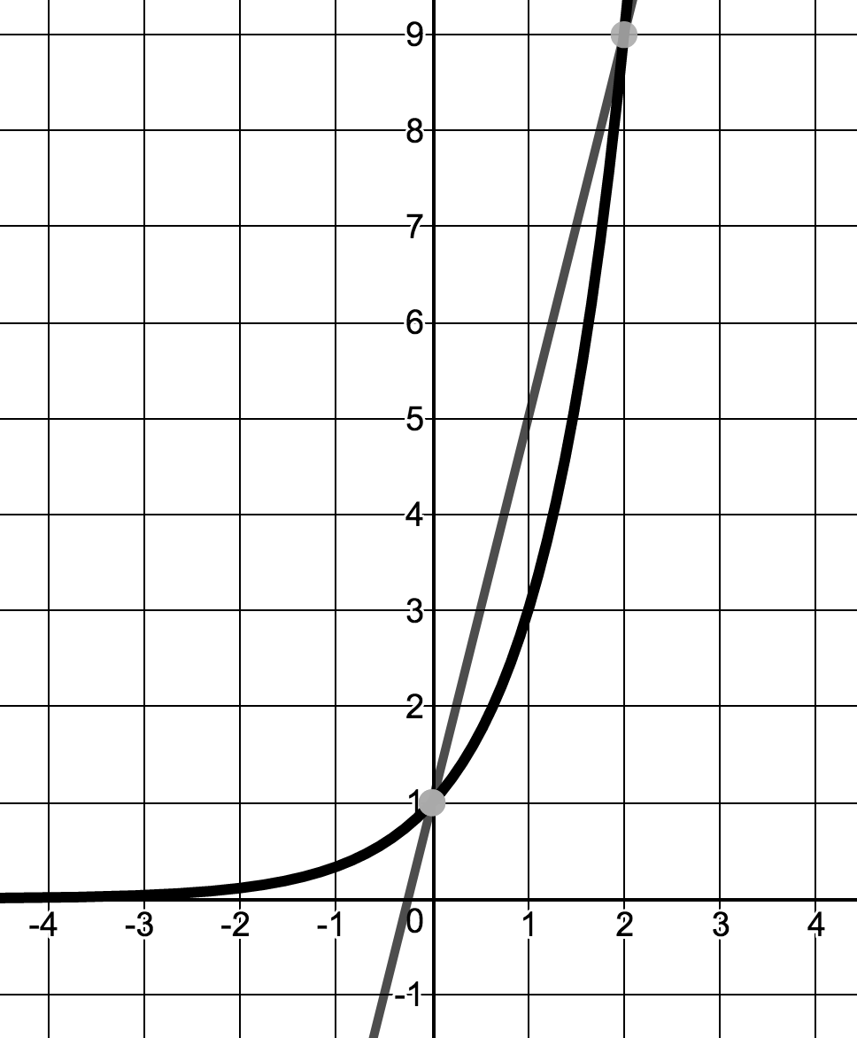
Use the following graph to answer questions #16-17.
(2,9)
16. Write an equation for $f(x)$
17. Write an equation for$g\left(x\right)$
$$f(x)$$
18. In the long run, which function will have a greater value? Explain.
$$g(x)$$
Determine whether the following situations are discrete or continuous.
Explain why.
19. Water flows down the Mississippi river at about 1.2 miles per hour.
20. An arithmetic sequence with a first term of 2 and common difference of 4.
$$(0, 1)$$
21. Bacteria steadily grow on an old abandoned house, quadrupling the
amount of bacteria each day.
22. Sally has 100 golf balls in a container. Every hour, she removes 3 balls to
take with her to the putting green.
23. Sam owns a movie theater and wants to track the amount of money his theater has made after selling each ticket.

- The Lake of Distress is contaminated with flesh-eating bacteria! The lake started with only 4 square feet infected, but as time has gone on, the bacteria are growing by a factor of 3 every hour. Assume that the relationship between hours and square feet of bacteria is continuous. Answer the following questions:

- Is the relationship linear or exponential?

- The relationship is…
  - A sequence because there is a pattern of multiplying by 3 every hour
  - A sequence because there is a pattern of adding 3 every hour
  - Not a sequence because there is no pattern
  - Not a sequence because it is continuous

- Based on your answer to #24B the relationship…
  - Is a sequence, and the sequence type is arithmetic
  - Is a sequence, and the sequence type is geometric
  - Is not a sequence but is linear
  - Is not a sequence but is exponential

- What is the DOMAIN of the function in #24?
  - $\left\{x | x∈N\right\}$
  - $\left\{x | x∈Z, x≥0\right\}$
  - $\left\{x | x∈Q, x≥0\right\}$
  - $\left\{x | x∈R, x≥0\right\}$

- Which of the following functions describes the relationship from #24 above?
  - $f\left(x\right)=4∙3^{x}$
  - $f\left(x\right)=4+3x$
  - $f\left(x\right)=3∙4^{x}$
  - $f\left(x\right)=3+4x$

25. A discrete relationship is shown below between the number of students in the group project and the number of pages written.
Students | Number of Pages Written
1 | 3
2 | 6
3 | 9
4 | 12

- Is the relationship linear or exponential?

- The relationship is…
  - A sequence because there is a pattern
  - A sequence because the domain of the relationship is the natural numbers
  - Not a sequence because there is no pattern
  - a and b

- The relationship…
  - Is a sequence, and the sequence type is arithmetic
  - Is a sequence, and the sequence type is geometric
  - Is not a sequence and therefore not linear
  - Is not a sequence and therefore is not exponential

- What is the DOMAIN, in set notation, for the situation above?
  - $\left\{x | x∈N\right\}$
  - $\left\{x | x∈Z\right\}$
  - $\left\{x | x∈Q\right\}$
  - $\left\{x | x∈R\right\}$

- Which of the following functions describes the relationship above?
  - $f\left(x\right)=3{\left(3\right)}^{x}$
  - $f\left(x\right)=2{\left(3\right)}^{x}$
  - $f\left(x\right)=3(x-1)+3$
  - $f\left(x\right)=3x$

